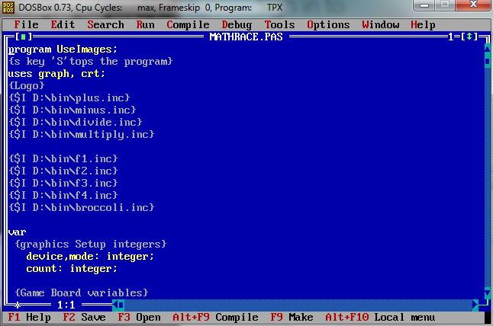

Editing Screen: Shows the image files used.

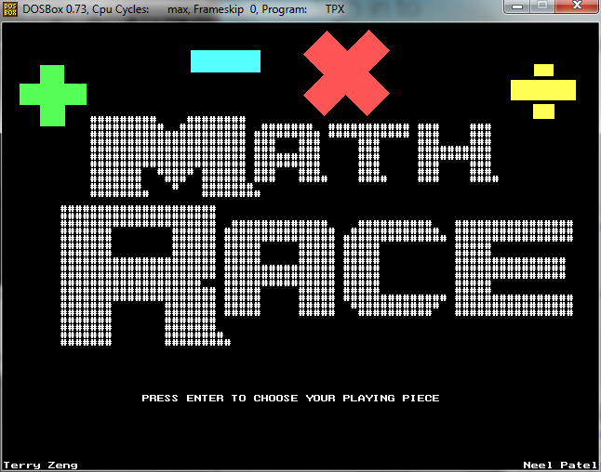

Title screen of the Program

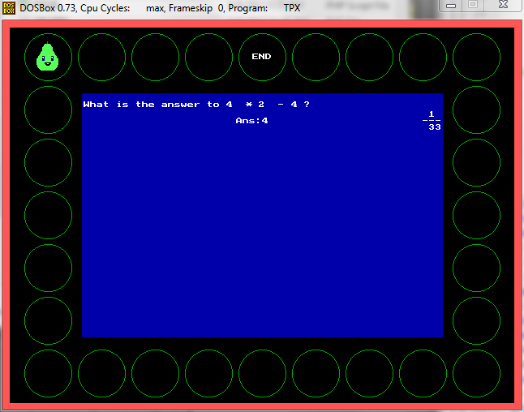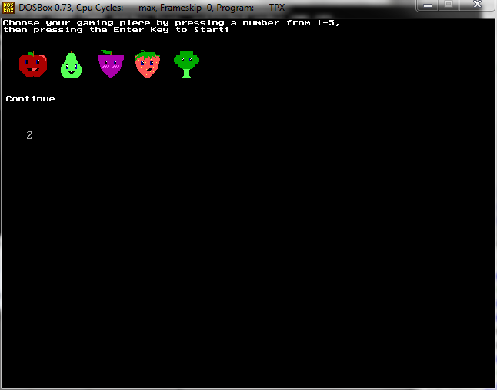 Choosing the game piece Playing the game

Please note: The screenshot on the right has the answer on it. This was only for the intention of saving time. It can be removed by editing the program.

Variables

|  |  |  |
| --- | --- | --- |
| NAME OF VARIABLE | TYPE | DESCRIPTION |
| Device | Integer | Graph Setup |
| Mode | Integer | GraphSetup |
| count | integer | Used for controlling “For to do” loops throughout the program |
| Mcount | integer | Used to Count how many times has the piece moved |
| x,y | Integer | (coordinates) Placing circles and images |
| a,b,c | integer | The 3 integers used in the equation. Random. Up to 20 for each variable. |
| Mdsign | integer | Decides if it is a multiply sign or div sign.  Random.  Multiply= * Divide = (shown as /) (operation performed: div) |
| Sasign | Integer | Decides if it is an addition sign or a subtraction sign. Random. Addtion= + Subtraction = - |
| Ph | String | Used to outtext a integer value (placeholder) by placing integer value on the string. |
| Ans | Integer | Answer of variable a and b |
| MainAns | Integer | Answer of the entire 3-variable equation |
| UserAns | Integer | The User Input which is compared with the MainAns |
| PieceChoice | Integer | User Input: 1-5 to choose a piece |
| Px,Py | Integer | Piece Coordinates: Decides where the piece will be placed using a series of equations. |
| LowPx,LowPy | Integer | The Lowest X and Y coordinate value for the game Piece |
| MaxPx,MaxPy | Integer | The Highest X and Y coordinate value for the game Piece |
| Logo | Text | The text variable: Used for opening the ascii art Logo.txt file |
| LineL | Array of string | Decides the number of lines and which one it will read. |
| Lx,Ly | integer | Lx: Which line to retrieve Ly: The Y value of which the outtext will go on the screen. |
| User | String | The User Name of the Player. |